Conversation Hour!
Join us!
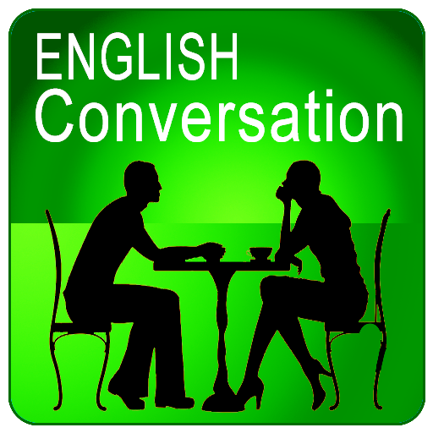
Transitional Studies Tutoring
Spring 2024 Conversation Hours

Monday | Tuesday | Wednesday | Thursday | Friday
Melanie  ZOOM  11am-1pm | Melanie  ZOOM  11am-1pm | Melanie  ZOOM  11am-1pm
Deborah  HKH 102  12pm-1pm | Deborah  HKH 102  12pm-1pm | Freya  HKH 102  12pm-1pm | Deborah  HKH 102  12pm-1pm

Visit the Language & Writing Center in Hawkins Hall (HKH) 102
to meet with Deborah, Freya, or Brian!
Click the time (above) to practice conversation with Melanie!

Email tutoring@clark.edu if you have questions or need more information.

