Headings Screenshot Tutorial

Step 1
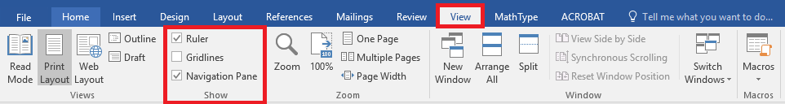

Step 2

Step 3
