ECON 201 Microeconomics
Homework 4
Chapter 12
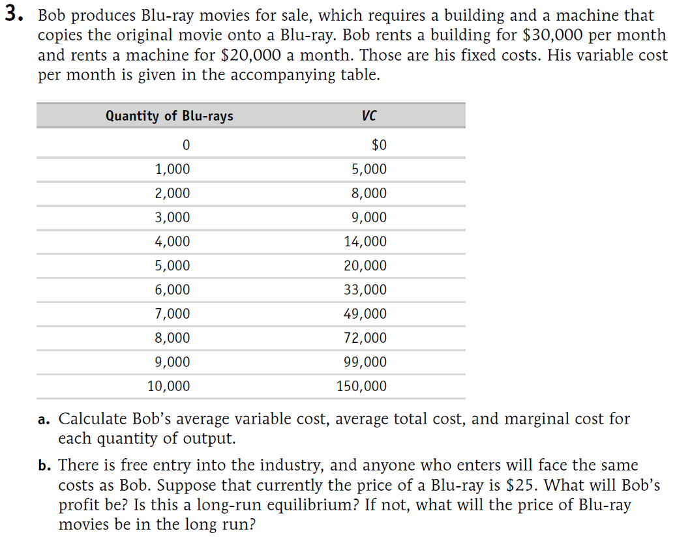
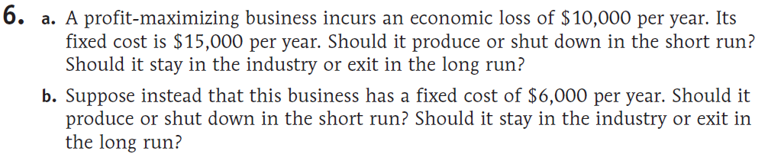

Chapter 13
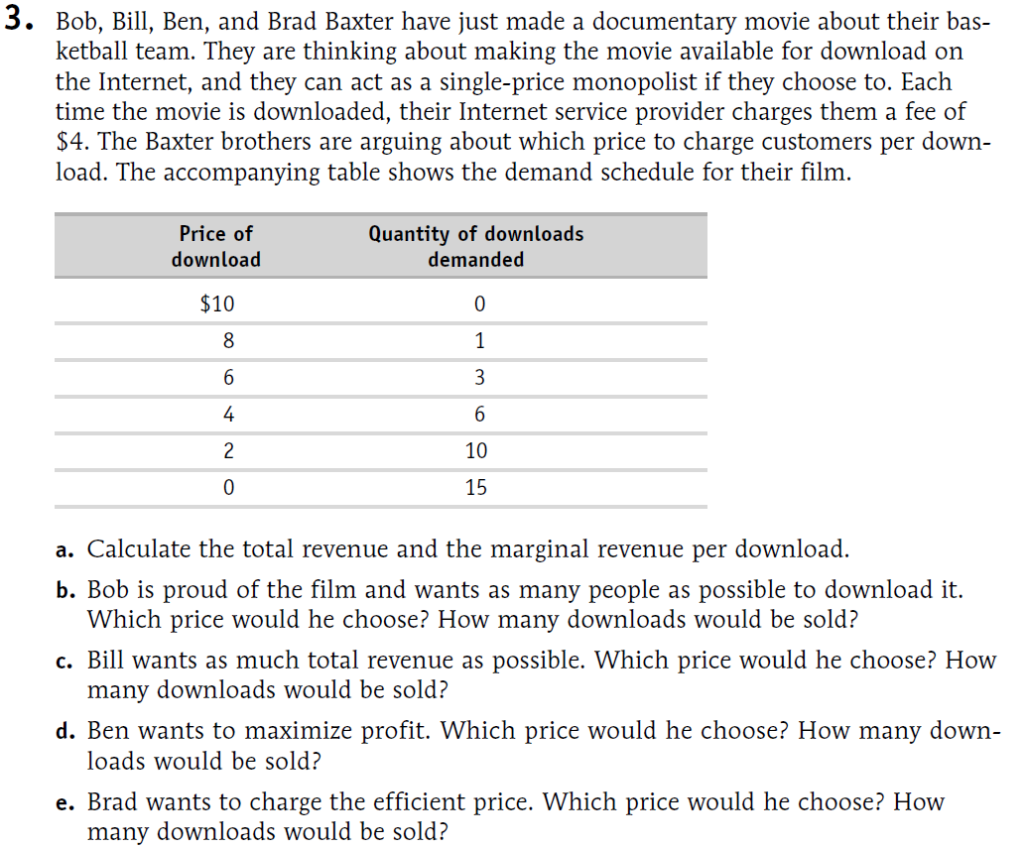
Chapter 15
